Figure 16: Denderah Circular Zodiac
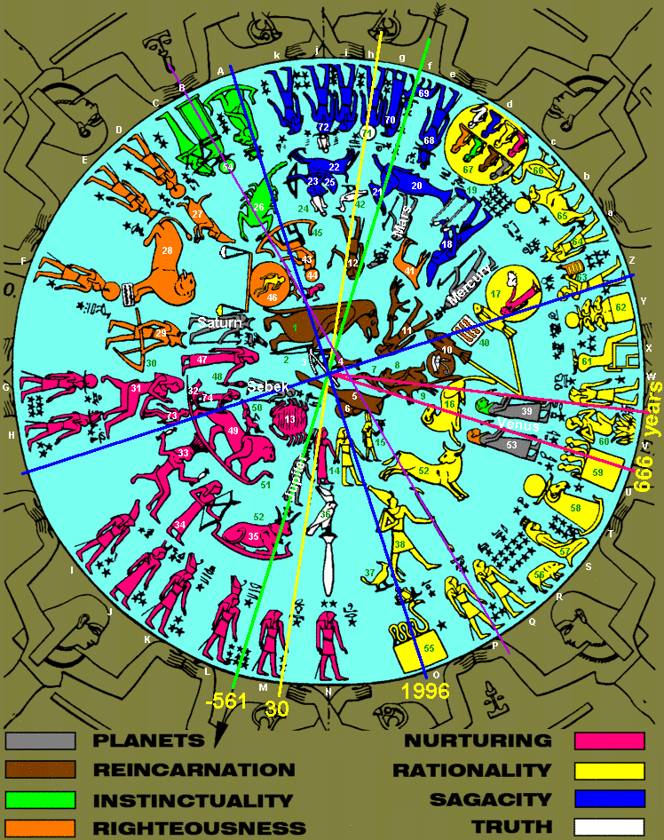

Denderah Zodiac, Table of Icons
 | Icon | Denderah | Constellation | Constellation
# | Description | Mythological Meaning | Latin Name (*Ptolemy) | Figurative Meaning
1 | Draco | Tauret, Material Mother | Draco* | The Dragon
2 | Construction Angle | Angle Code, 666 Years | Circinus | The Compasses
3 | Little Dipper | Plow of Truth | Ursa Major* | The Great Bear
4 | Lupus | Anubus, Material Grave | Lupus | The Wolf
5 | Taurus | Past Age, Leg of Bovine | Taurus* | The Bull
6 | Aries | Dieing Age | Aries* | The Ram
7 | Triangulum-Falcon | Cognition | Triangulum* | The Triangle
8 | Triangulum-Baboon | Sensual | Triangulum* | The Triangle
9 | Triangulum-Goat | Rational | Triangulum* | The Triangle
10 | Pisces-Ucthat | Tabernacle of Sun, Equinox | Pisces* | The Fishes
11 | Perseus | Angel of Death | Perseus* | Rescuer of Andromeda
12 | Hercules | Warrior, Alexander | Hercules* | The Son of Zeus
13 | Cancer | Khephera, Father in Heaven | Cancer* | The Crab
14 | Gemini | I Think | Gemini* | The Twins
15 | Auriga | Shepherd | Auriga* | The Charioteer
16 | Aries | I Am | Aries* | The Ram
17 | Pisces-Rock/Lizard | Bondage, I Believe | Lacerta | The Lizard
18 | Aquarius | I Know | Aquarius* | The Water-Bearer
19 | Pisces Austrinis | Carries Phallus of Osiris | Piscis Austrinus* | The Southern Fish
20 | Cetus | Massive Physical Strength | Cetus* | The Whale
21 | Capricorn | I Use | Capricornus* | The Goat
22 | Centaurus | Barabbas, Piracy | Centaurus* | The Centaur
23 | Sagittarius | Archer | Sagittarius* | The Archer
24 | Corona A. | War Crown | Corona Australis* | The Southern Crown
25 | Aquila | Reason | Aquila* | The Eagle
26 | Scorpio | I Desire | Scorpius* | The Scorpion
27 | Little Dipper-Antinous-Corona B. | Material-Body Birth | Virgo Minor* | The Dreaming Youth
28 | Lynx-Leo | Teacher of Righteousness | Lynx* | The Lynx
29 | Bootes | Husband of Virgo | Boötes* | The Herdsman
30 | Big Dipper | Plow | Ursa Major* | The Great Bear
31 | Cassiopeia-Corvus | Queen, History Lesson | Cassiopeia* | The Queen
32 | Corvus | Crow, History | Corvus* | The Crow
33 | Crater | Vessel of Responsible Love | Crater* | The Cup
34 | Sextans | Selket, Youthful Motivation | Sextans | The Sextant
35 | Canes Major-Argo | Hathor, Laurels, Mother Earth | Canis Major* | The Big Dog
36 | Columba, Bough of Tree, Truth | Dove, Falcon, Son of God | Columba | The Dove
37 | Phoenix | Phoenix, Resurrection | Phoenix | The Phoenix
38 | Orion | Son of Man, Cock Sure Fear | Orion* | The Hunter
39 | Sculptor-Lioness | Venus, Sensitivity, Dominion | Sculptor | The Sculptor
40 | Pegasus-Great Square | Word of God, Temple Door | Pegasus* | The Winged Horse
41 | Andromeda-Pegasus-Centaurus | Personal Sacrifice | Andromeda* | Daughter of Cassiopeia
42 | Grus | Stork, Rebirth | Grus | The Crane (bird)
43 | Ophiuchus-Cepheus-Argo-Antila | Ra, Father, Judge | Ophiuchus* | The Serpent-Bearer
44 | Cepheus | Chronos, Ruler of Time | Cepheus* | The King
45 | Argo-Antila | Pilot of Sun Boat | Antlia | The Air Pump
46 | Libra-Antinous | I Balance, Trial of Youth | Libra* | The Balance
47 | Virgo | I Analyze | Virgo* | The Maiden
48 | Coma Berenices | Wheat, Manna, Seed of Tomorrow | Corona Borealis* | The Northern Crown
49 | Leo | I Will, Kingdom of Heaven | Leo* | The Lion
50 | Corona Borealis-Leo Minor | Prince of Peace, Son of God | Corona Borealis* | The Northern Crown
51 | Hydra | Subliminal Accomplishment | Hydra* | The Water Snake (female)
52 | Taurus | Abundance | Taurus* | The Bull
53 | Sculptor-Woman | Human Love, Sentiment | Sculptor | The Sculptor
54 | Ara-Argo | Physical Beginning, Reincarnation | Ara* | The Altar
55 | Hydrus | Compressed Wisdom | Hydrus | The Water Snake (male)
56 | Lepus | Intuitive Self, Selfishness | Lepus* | The Hare
57 | Pleiades | Seven Sisters, Feminine Spirits | Taurus* | The Bull
58 | Aries | Rational Conviction, I Am Right | Aries* | The Ram
59 | Great Square, Serpens | Subliminal Word of God | Pegasus* | The Winged Horse
60 | Coma-Antinous | New Aeon, Zion, Seventh Heaven | Coma Berenices | Berenice's Hair
61 | Cepheus | Tyrannical Ruler, Chronos | Cepheus* | The King
62 | Great Square, Aries | Rational Word of God | Pegasus* | The Winged Horse
63 | Ptah, Rock of Andromeda, Sculptor | Creative Word, Law, Pure Light | Lacerta | The Lizard
64 | Anubis, Lupus | Materiality, Star Light | Lupus | The Wolf
65 | Aries | I Am a Great Shepherd | Aries* | The Ram
66 | Cygnus | Satisfaction | Cygnus* | The Swan
67 | Eight Kings, Rational Bondage | Self Limiting Paradigms | Lacerta | The Lizard
68 | Pavo | Thoth, Rational Wisdom | Pavo | The Peacock
69 | Aries | I Am a Humble Shepherd | Aries* | The Ram
70 | Serpens | Seshat, Spiritual Wisdom | Serpens* | The Serpent
71 | Antinous | Enlightenment, Solstice | Antinous | The Child in Swaddling Cloths
72 | Ara-Red Crown | Wisdom of Experience | Ara* | The Altar
73 | Antinous | Father Image, Yesterday | Antinous | The Child in Swaddling Cloths
74 | Virgo Minor | Mother Image, Tomorrow | Virgo Minor | The Dream of Eternal Youth
Letters A-Z and a-k represent 36 Decans and one Epagomenal period beginning with Instinctual Wisdom and Osiris.

